Before:

Reading is easier, too, in the new Reading view. You can collapse parts of the documents and focus on the text you want. If you need to stop reading before you reach the end, word remembers where you left of – even on other device. Video provides a powerful way to help you prove your point. When you click online video, you can paste in the embed code for the video you want to add, you can also type a keyword to search online for the video that best fits your document.

After:

R

eading is easier, too, in the new Reading view. You can collapse parts of the documents and focus on the text you want. If you need to stop reading before you reach the end, word remembers where you left of – even on other device. Video provides a powerful way to help you prove your point. When you click online video, you can paste in the embed code for the video you want to add, you can also type a keyword to search online for the video that best fits your document.

1. **Select the Word (in our Case R)**

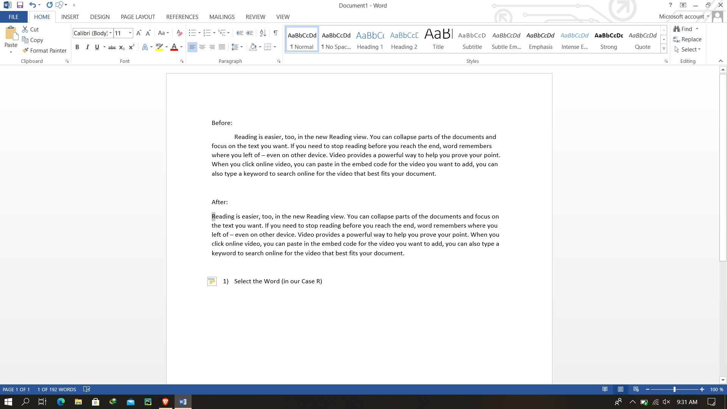

1. **Go to Insert**

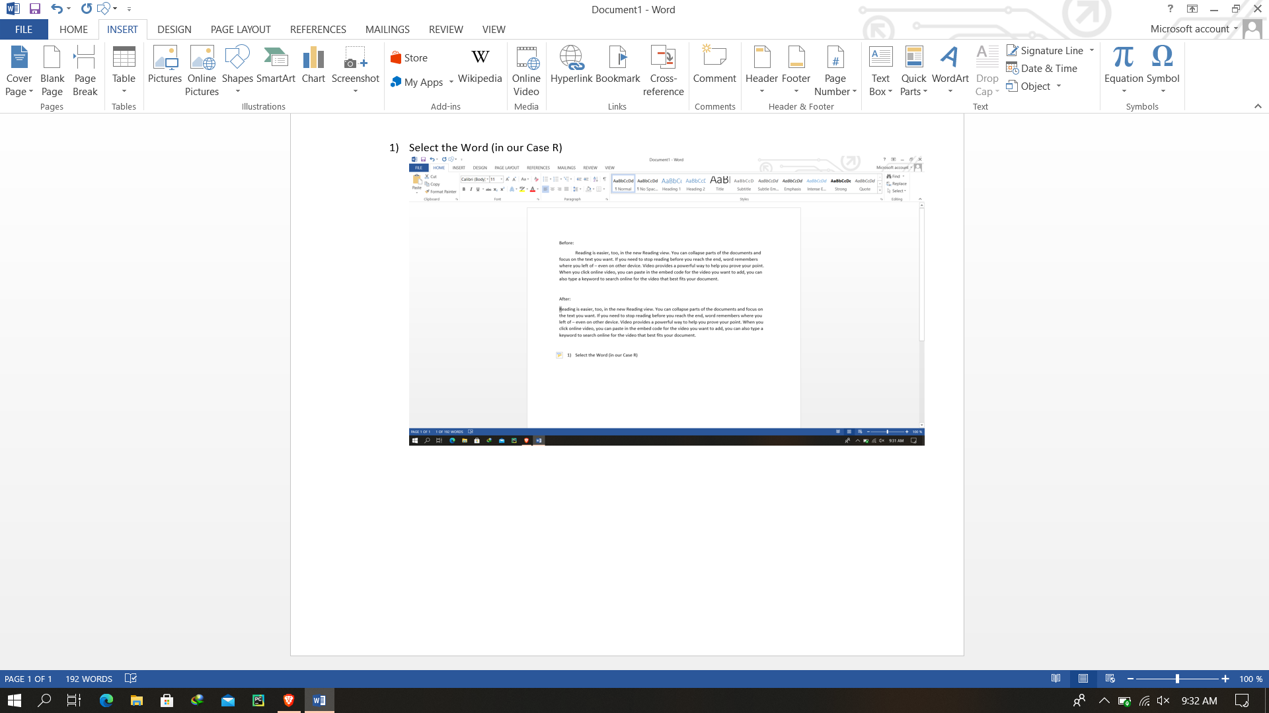

1. **Select Drop Cap**

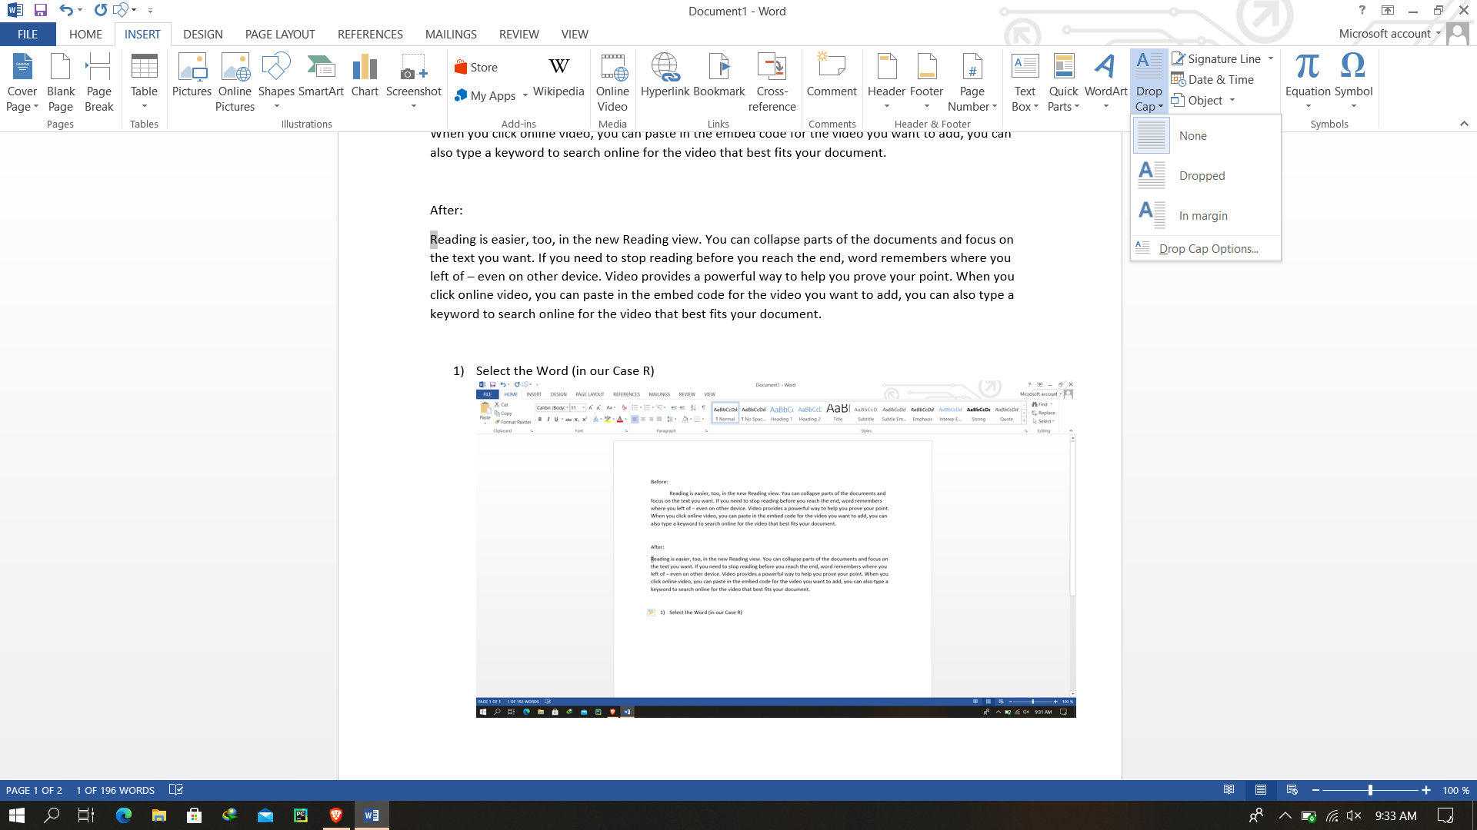

1. **Select Dropped**

